**Project 5:Launching the website using load balancer DNS name**

**Vpc created as nithin-vpc**

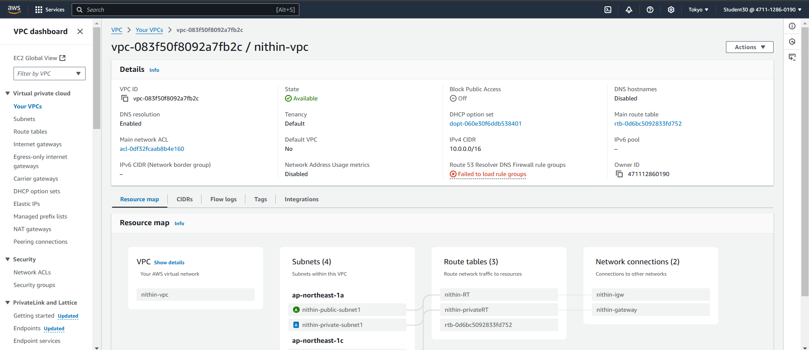

**Internet gateway created as nithin-igw**

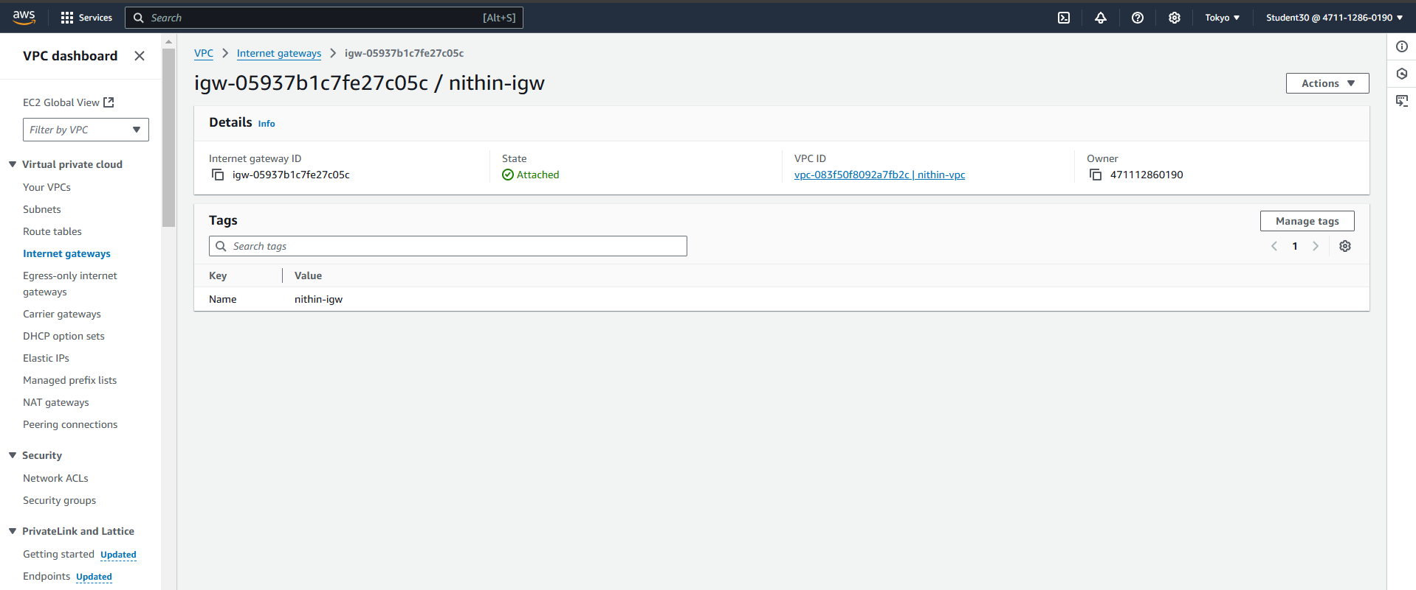

**public subnet is created as nithin-public-subnet-1**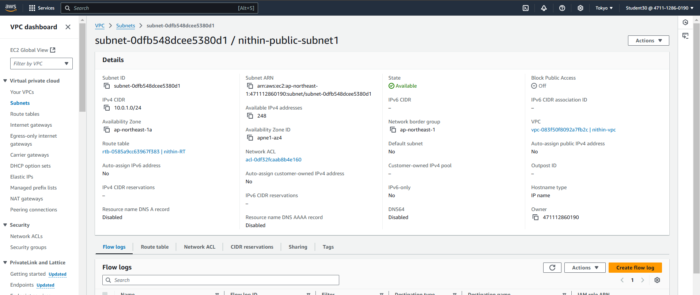

**public subnet is created as nithin-public-subnet-2**

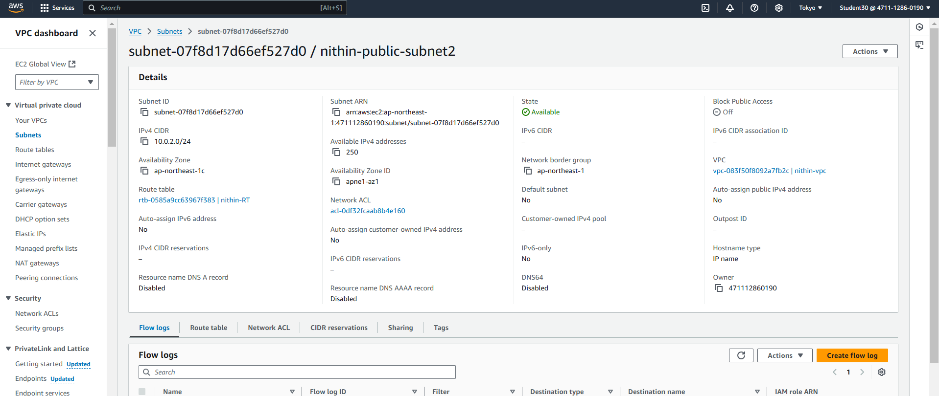

**private subnet is created as karthik-private-subnet-1**

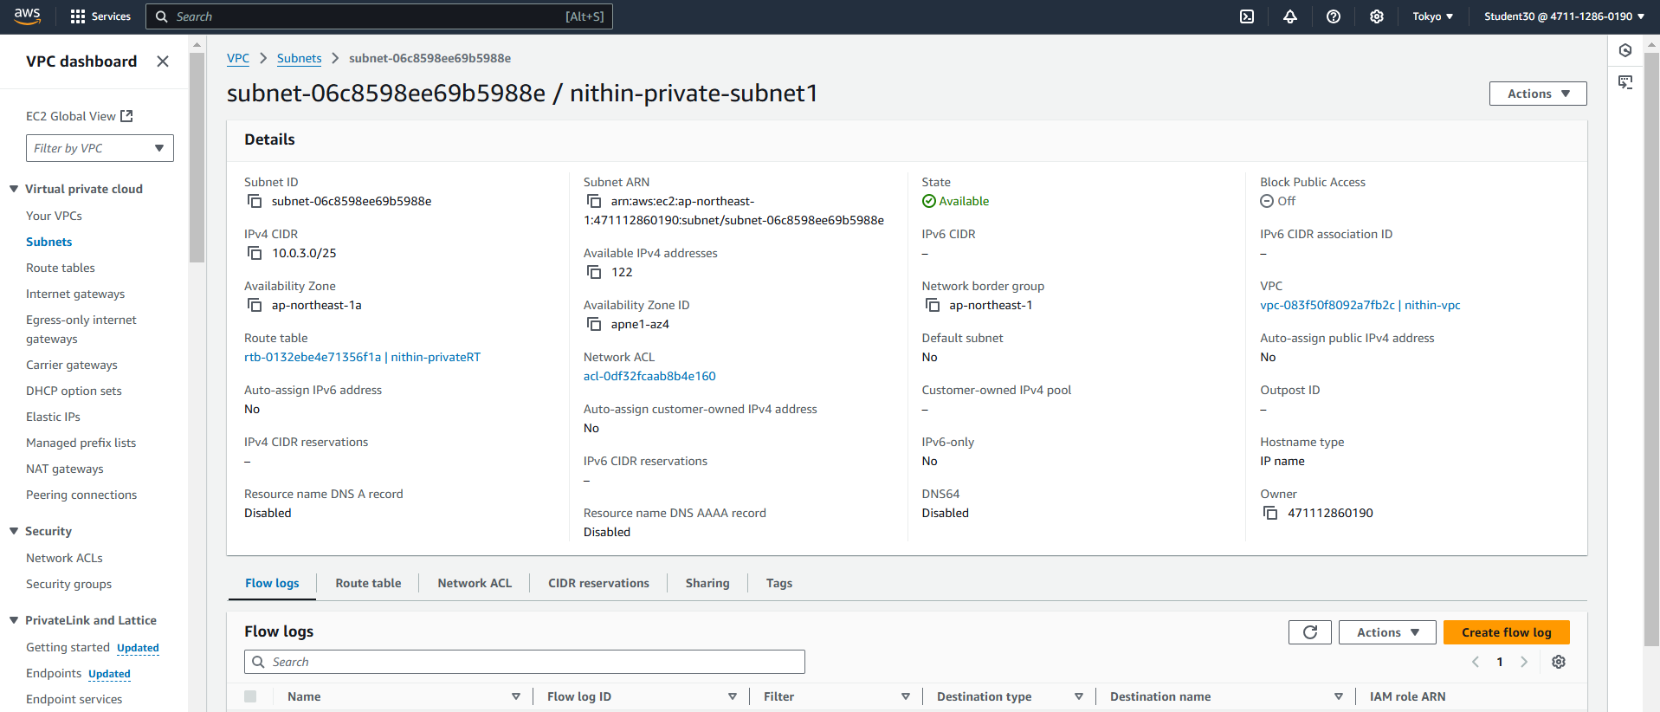

**private subnet is created as nithin-private-subnet-2**

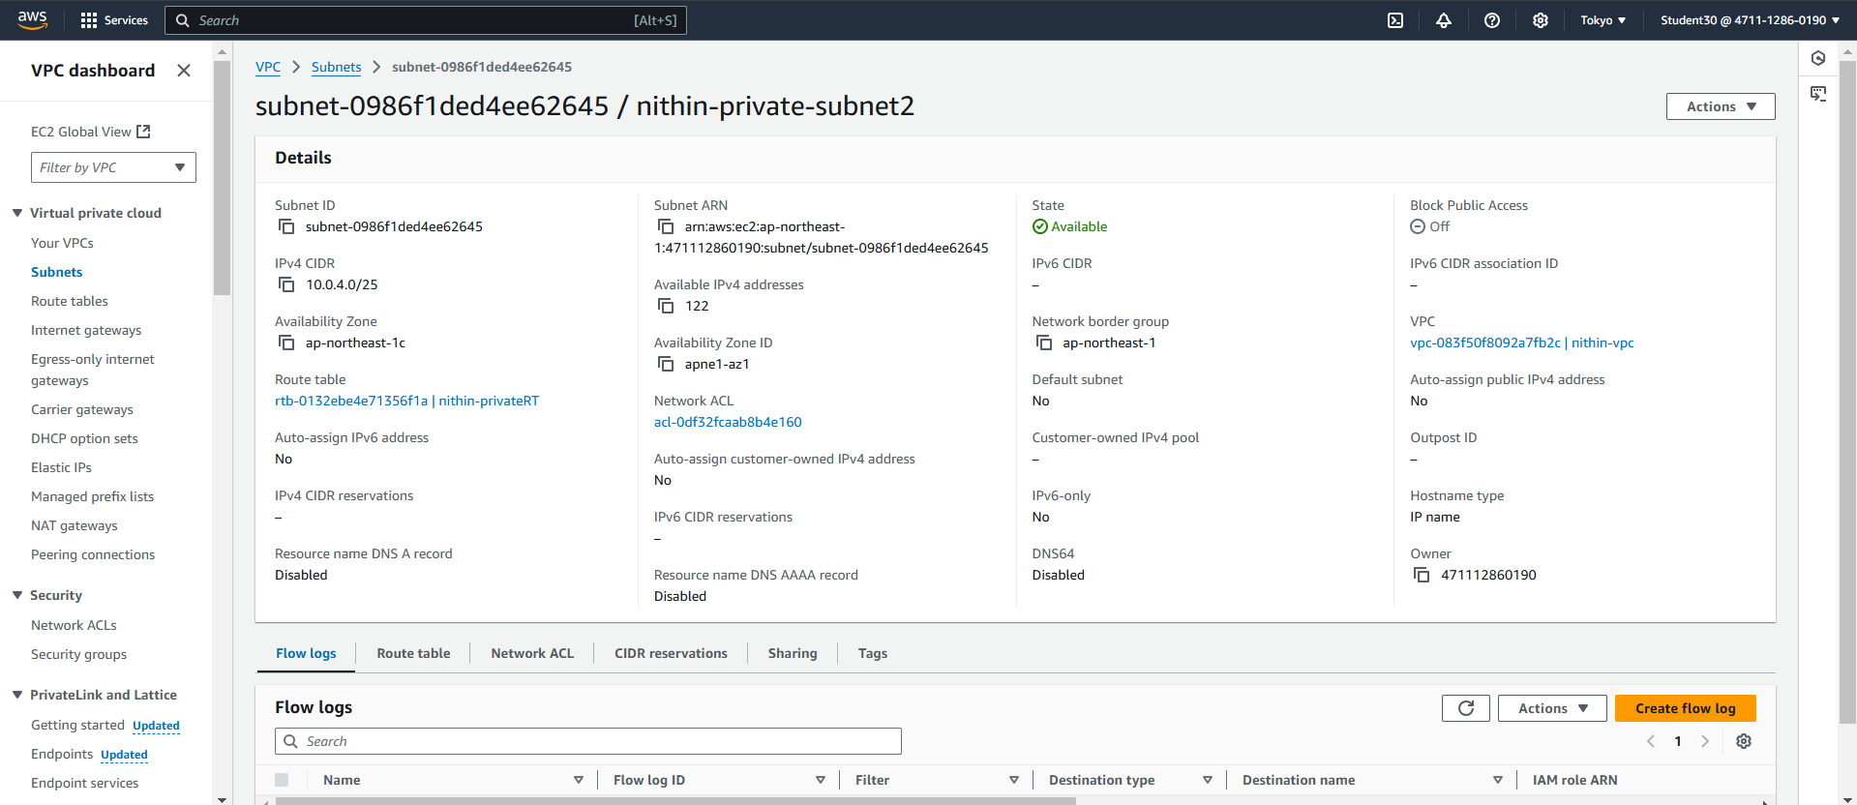

**public route table is created as nithin-RT**

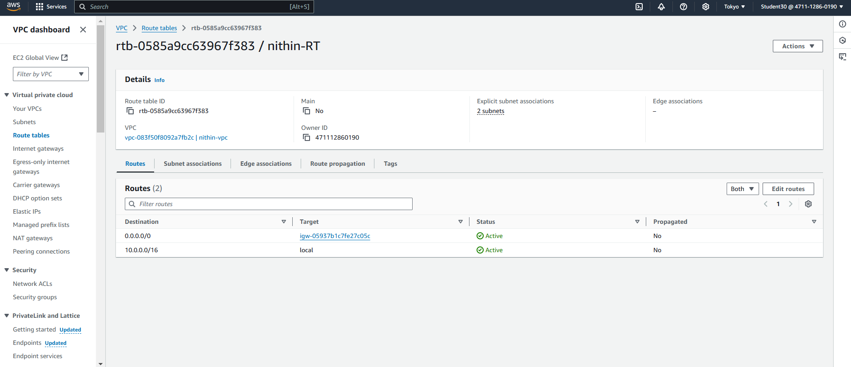

**k**

**private route table created as nithin-privateRT** 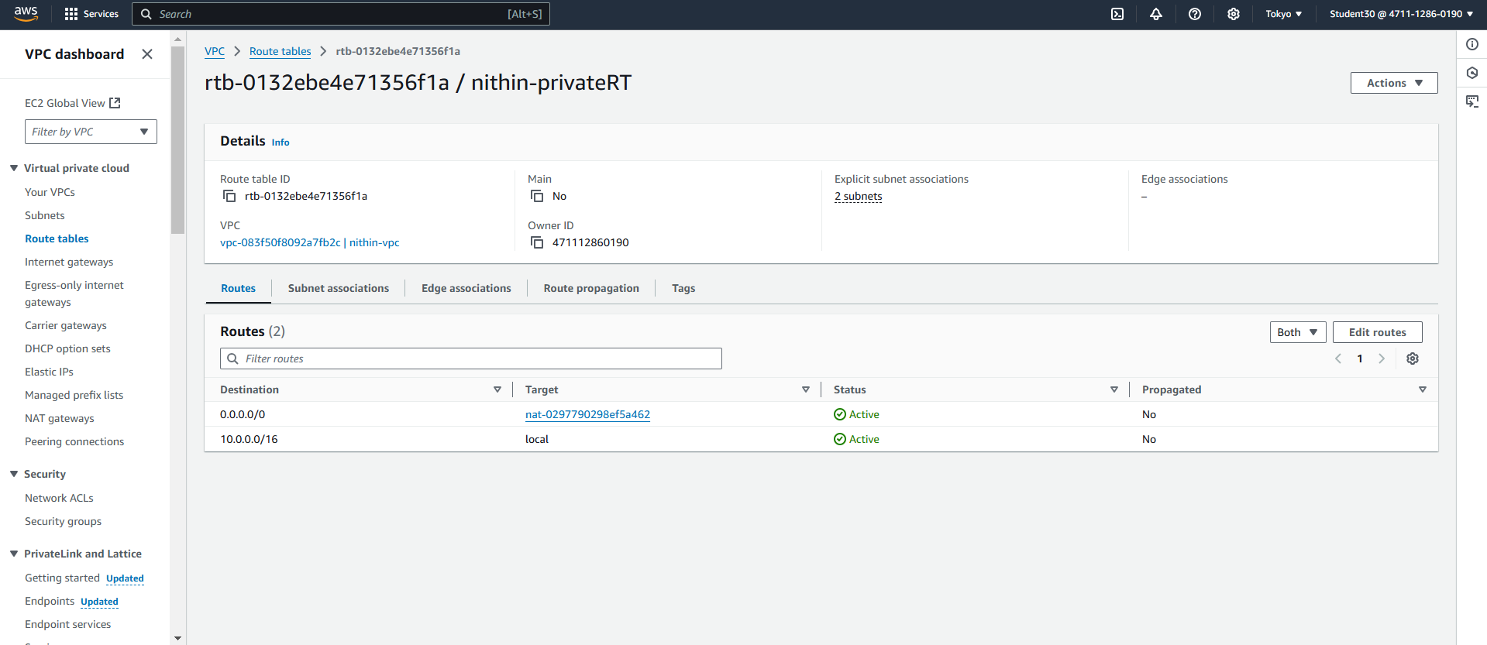

**Nat gateway is created as nithin-gateway**

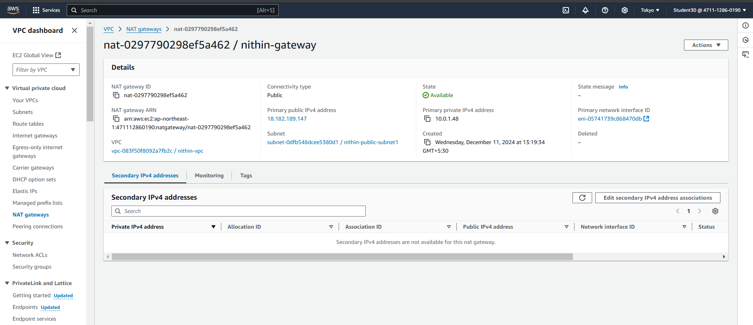

**Public server is created as nithin-jump-server**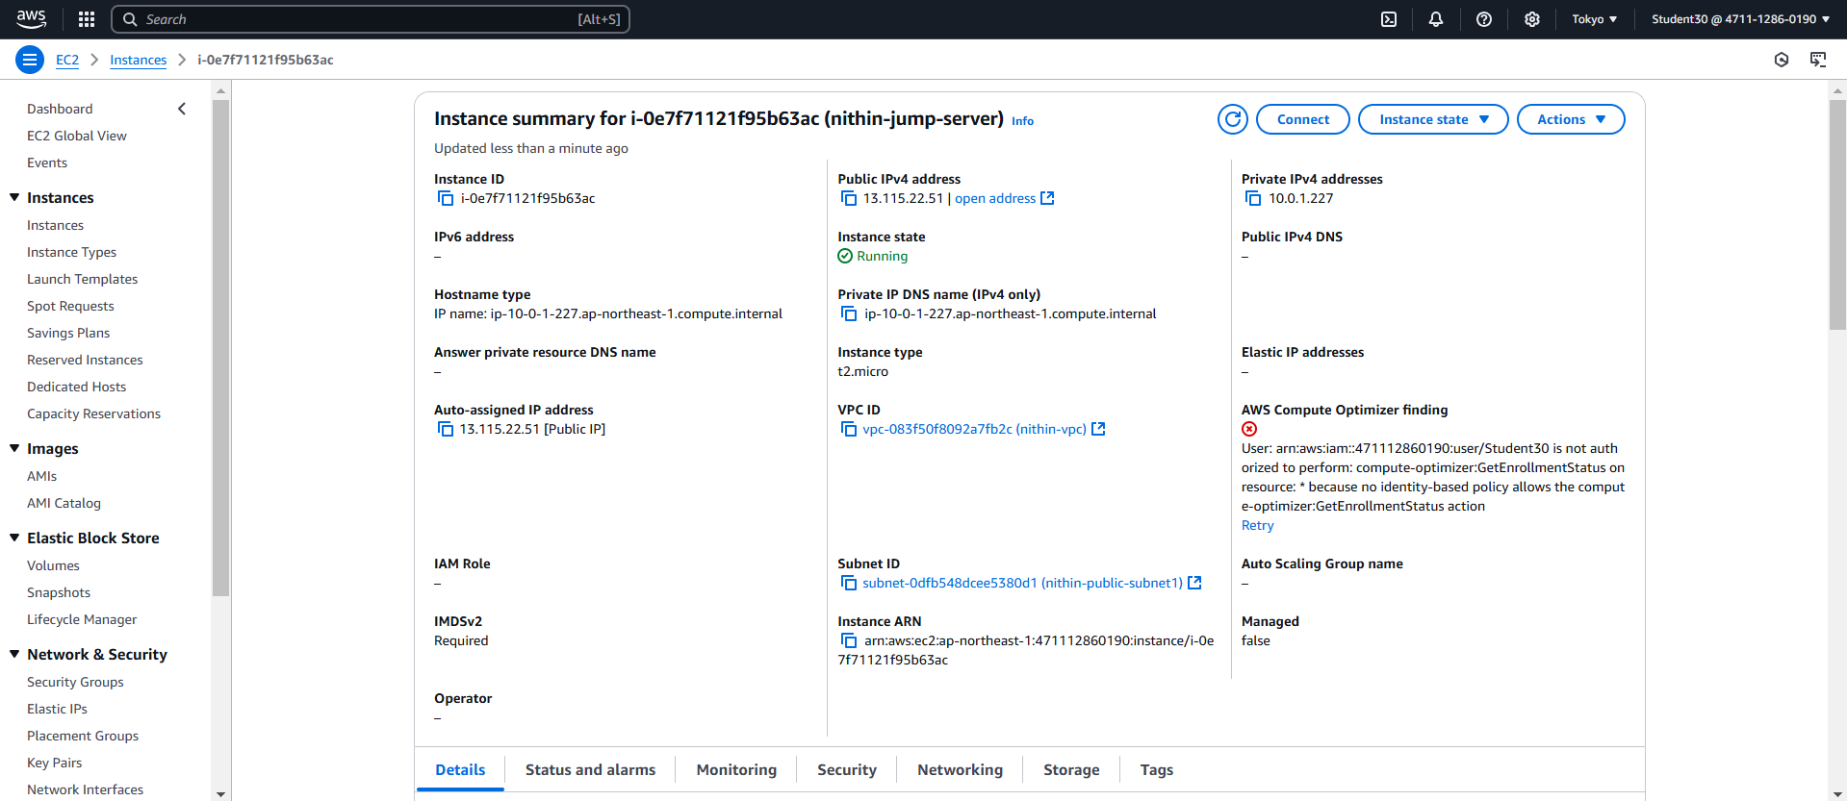

**Private server is created as nithin-private-server-1**

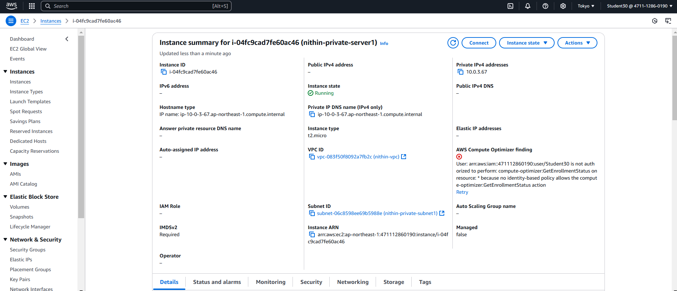

**Private server is created as nithin-private-server-2**

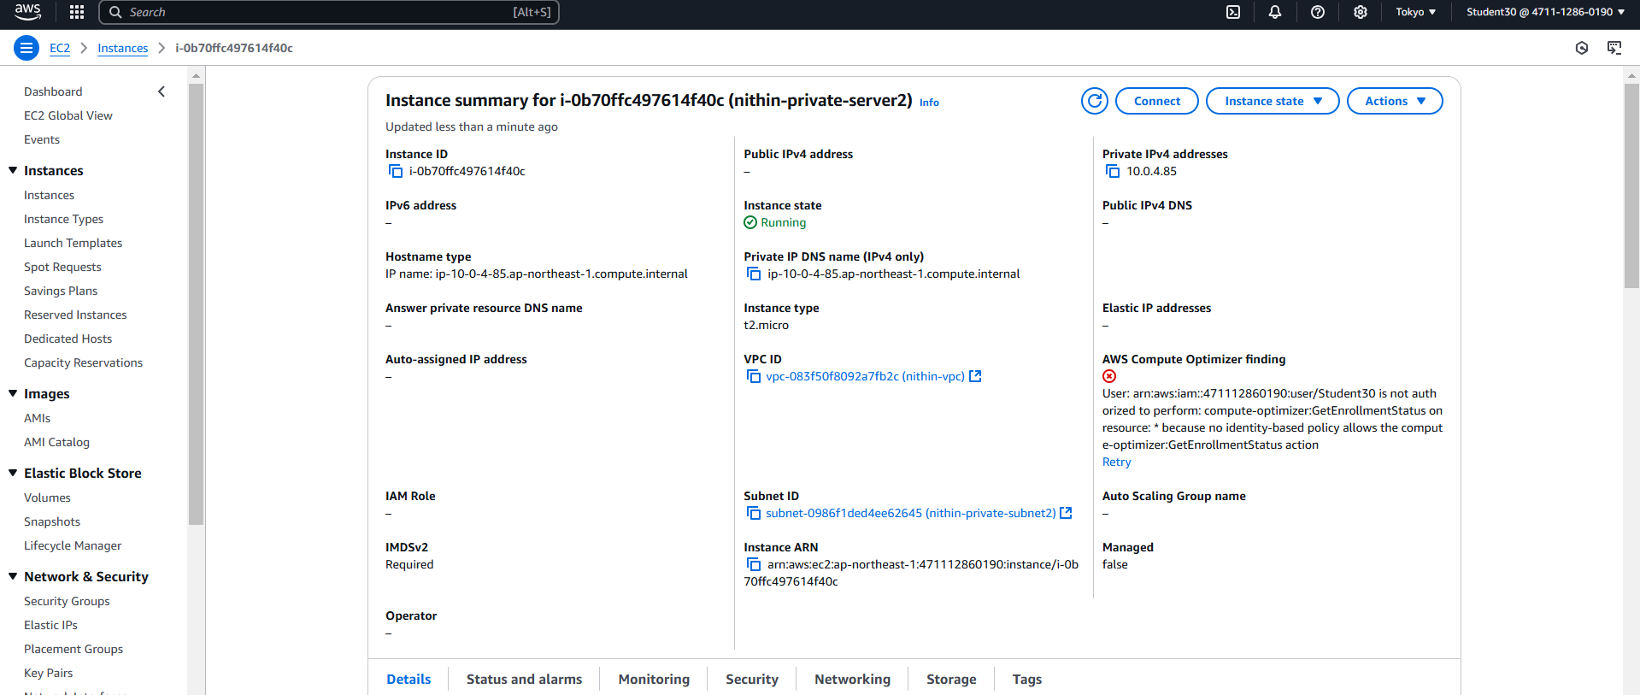

**Target group is created as nithin-TG01**

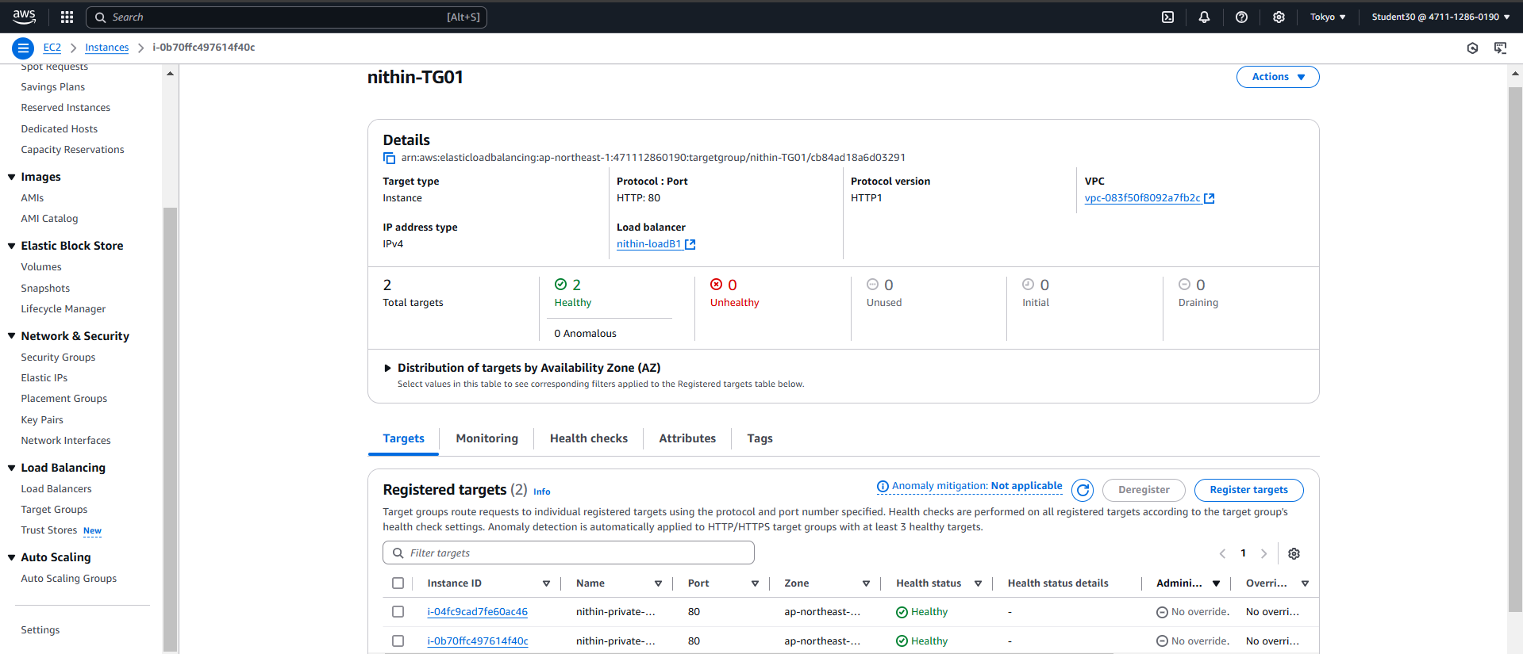

**Security group created as nithin-LB01**

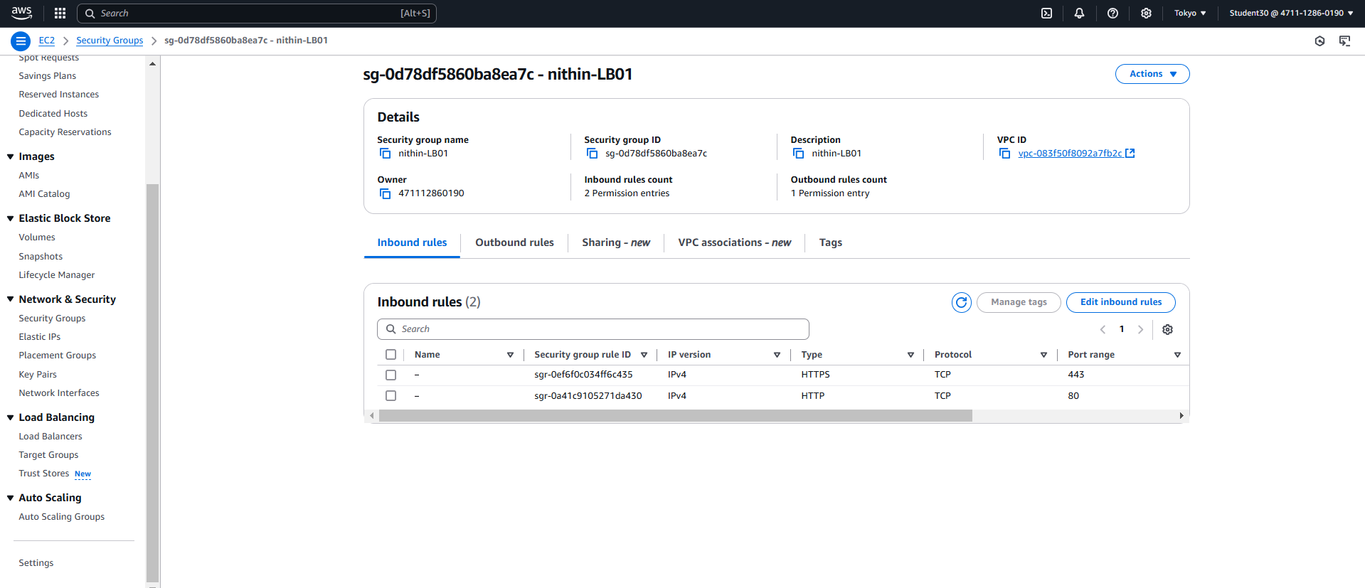

**load balancer is created as nithin-loadB1**

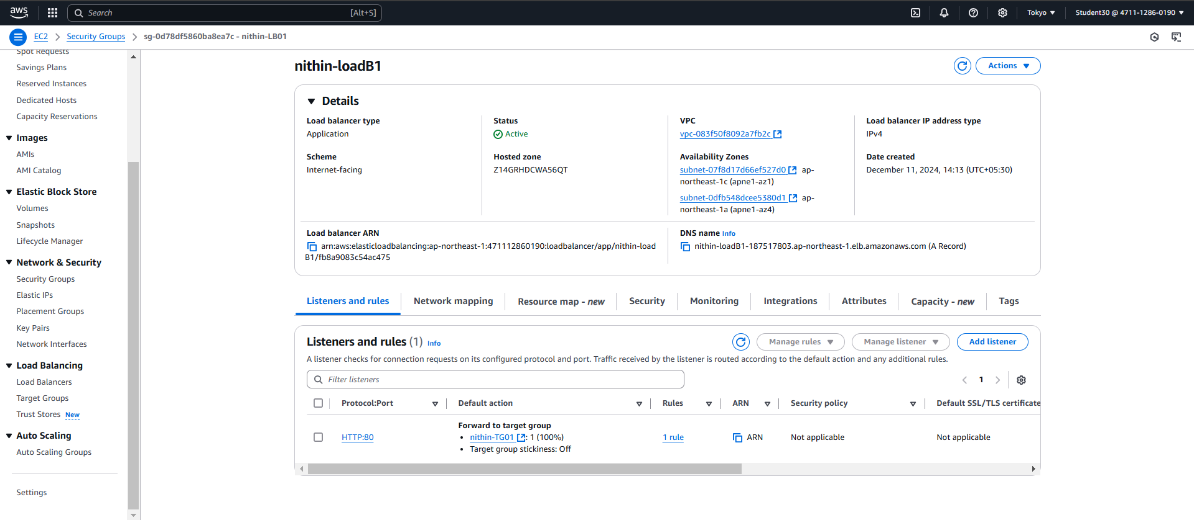

**Command prompt**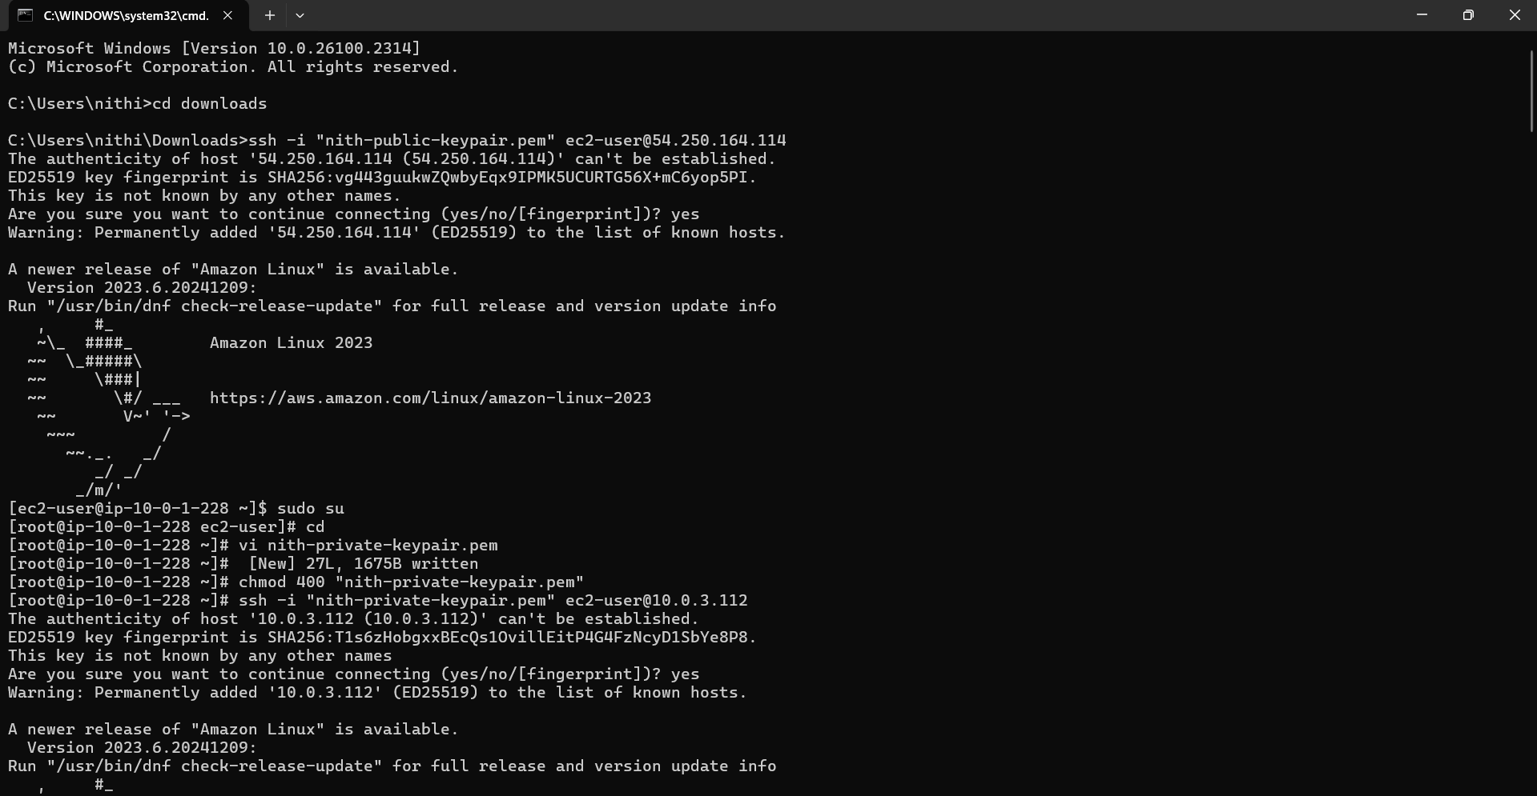

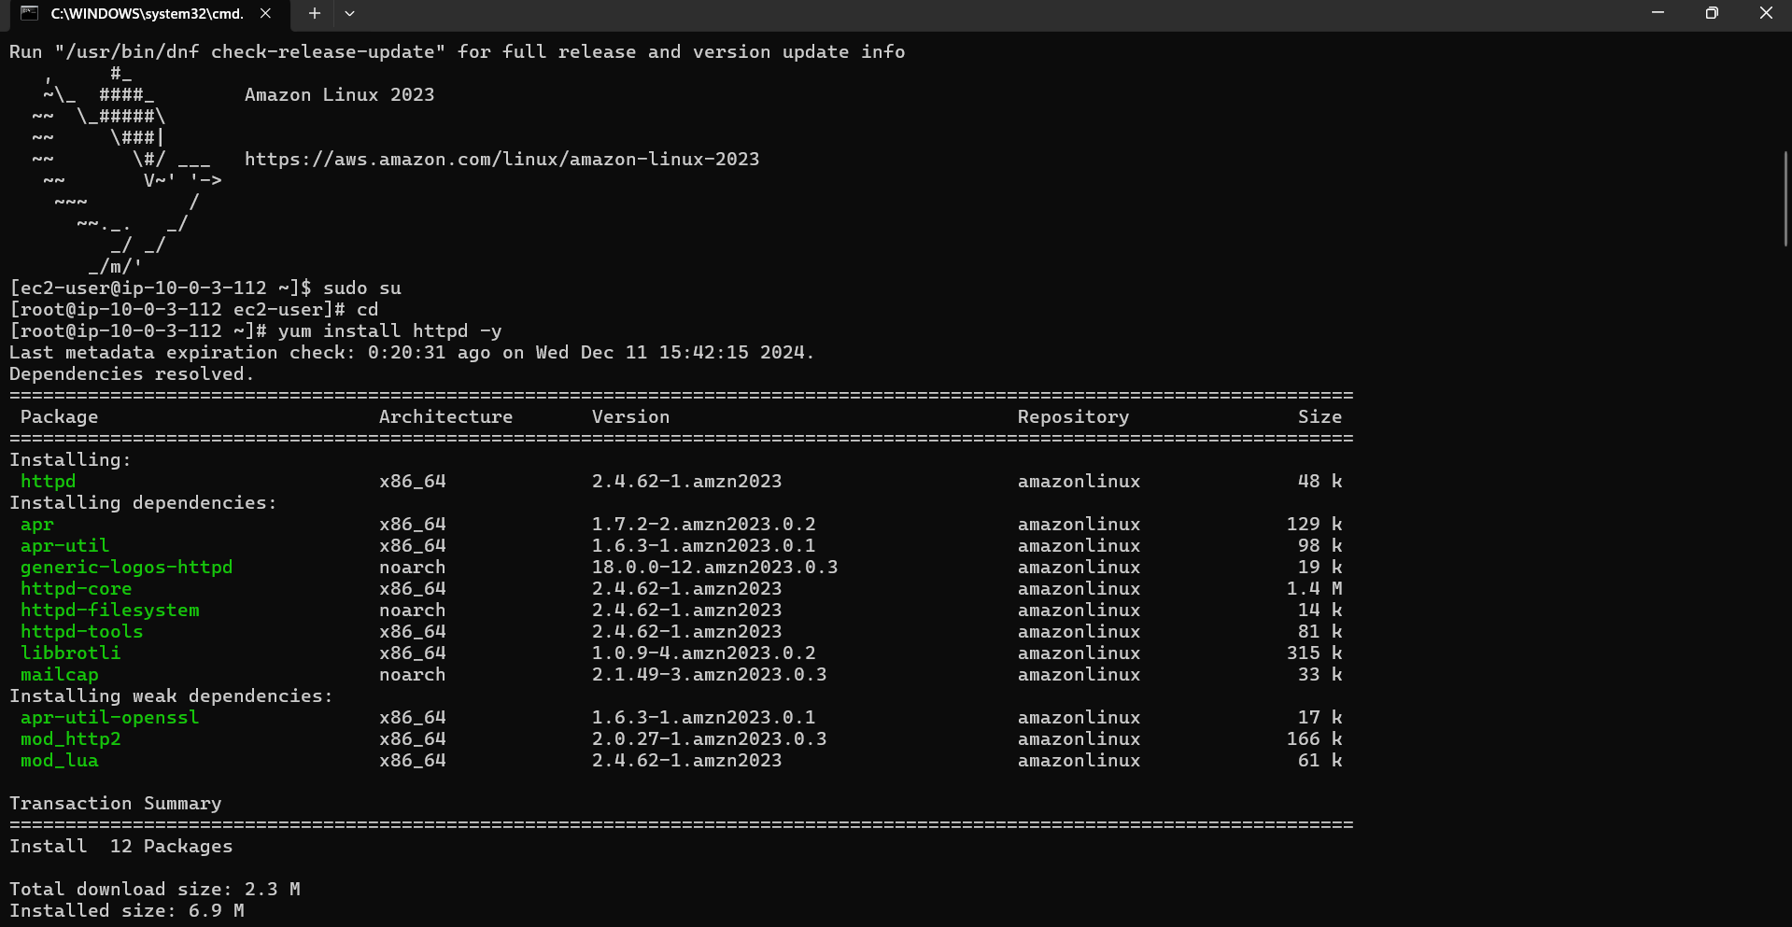

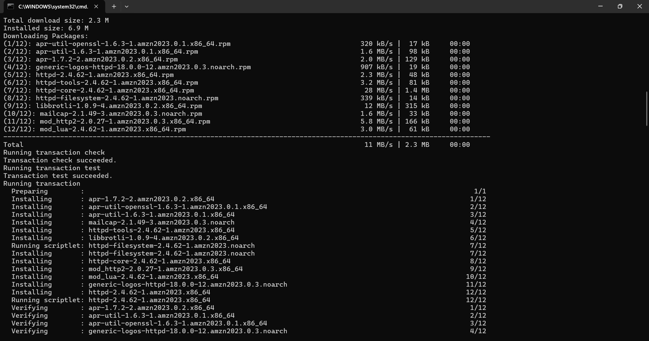

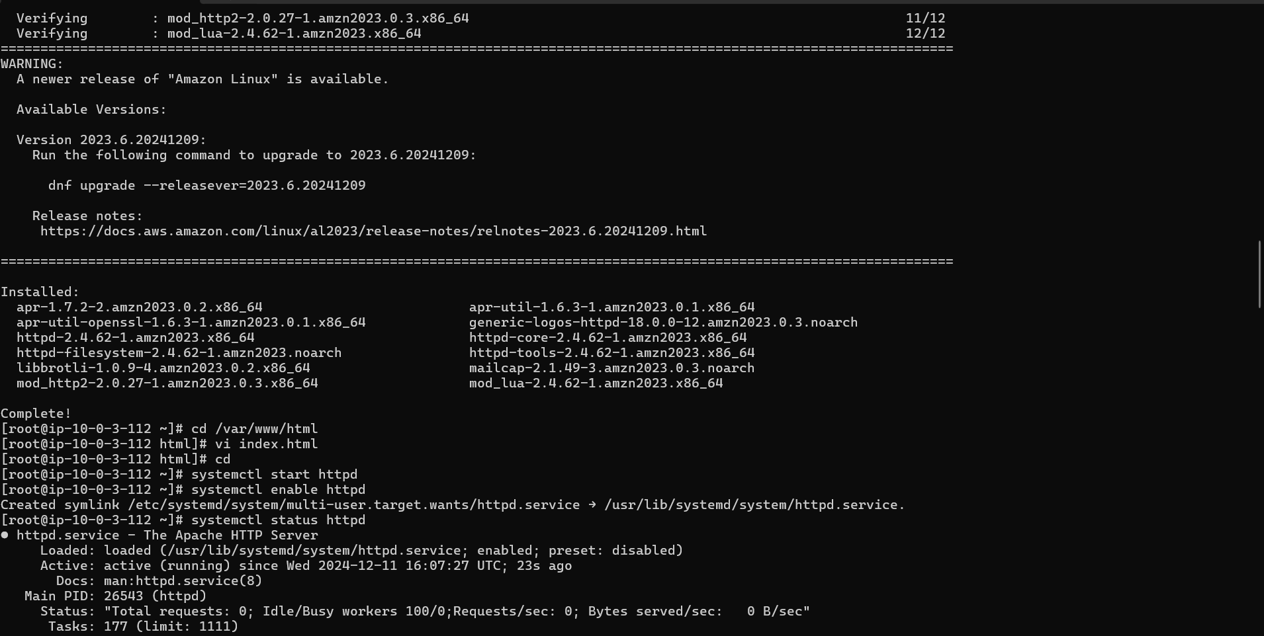

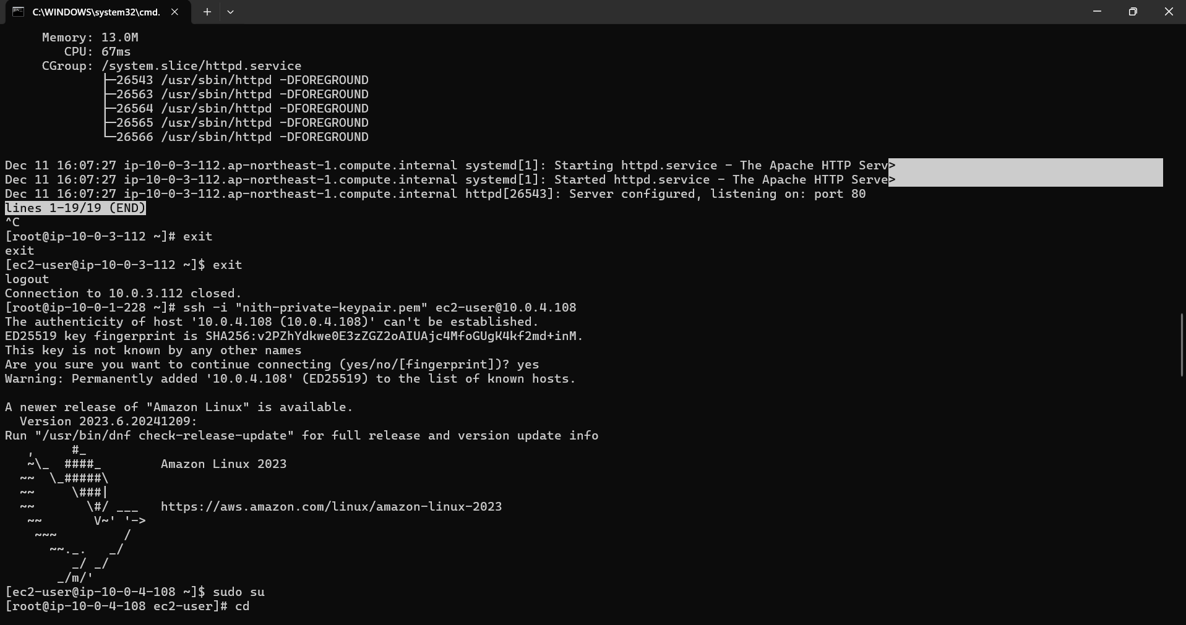

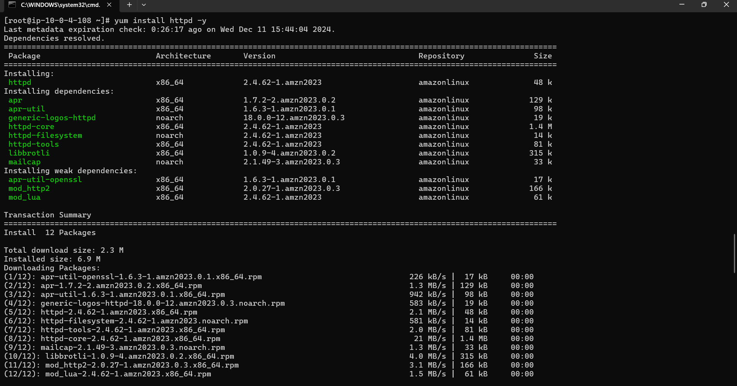

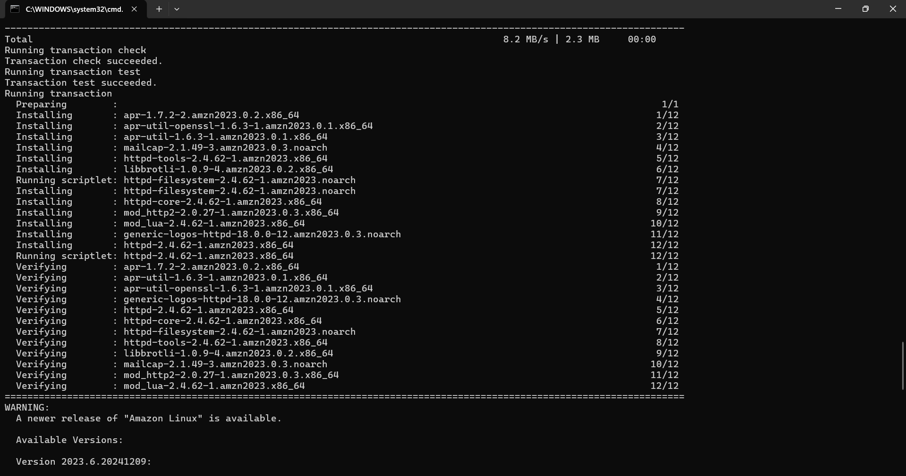

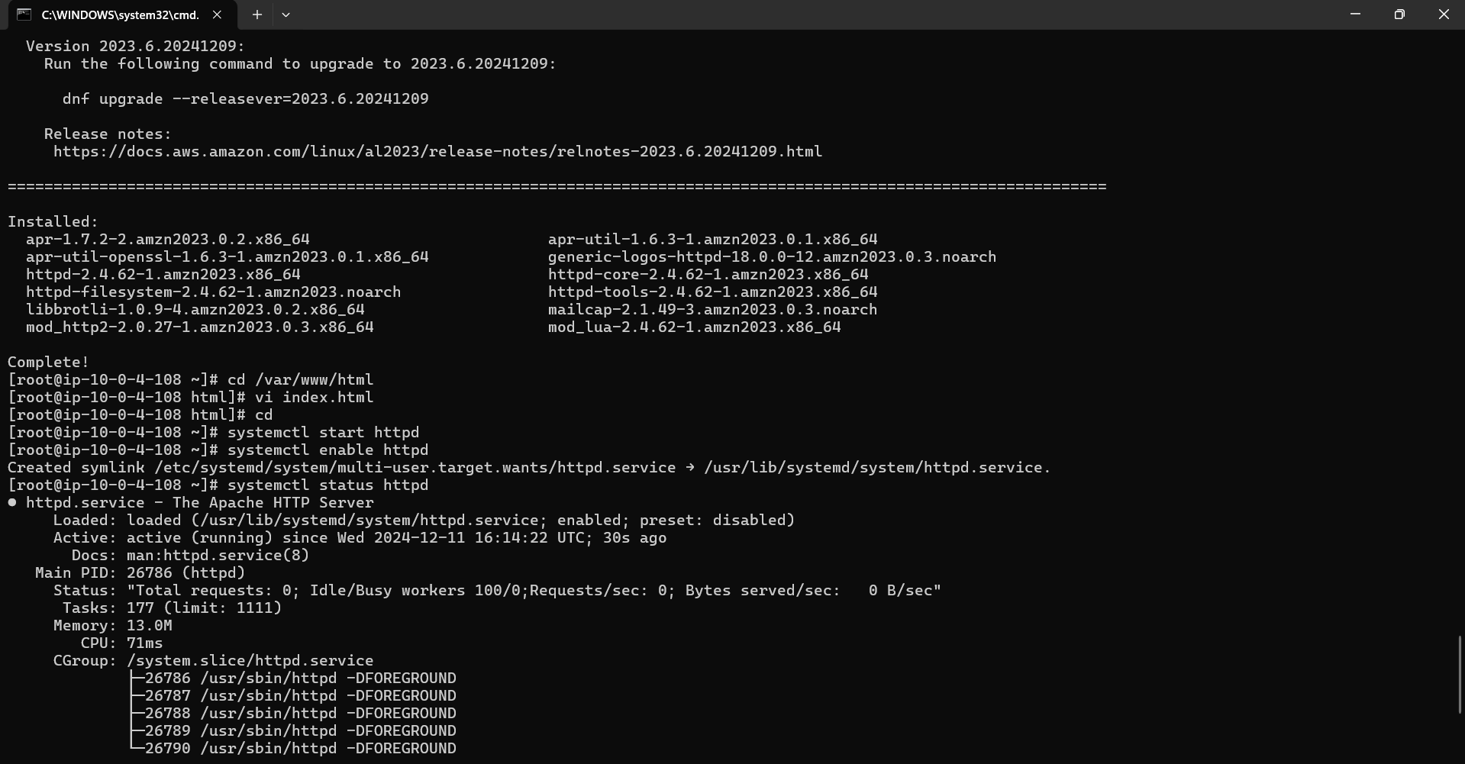

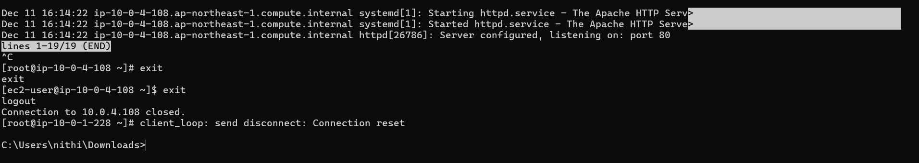

**Final output**